QUANTITATIVE MODULE
Decision-Making Tools

Discussion Questions
1. The 6 steps of the decision process are:
1. Clearly define the problem and the factors that influence it.
2. Develop specific and measurable objectives.
3. Develop a model.
4. Evaluate each alternative solution.
5. Select the best alternative.
6. Implement the solution.
2. The purpose of this question is to make students use a personal
experience to distinguish between good and bad decisions. A “good”
decision is one that is based on logic and all available information.
A “bad” decision is one that is not based on logic and all avail-
able information. It is possible for an unfortunate or undesired out-
come to result from a “good” decision (witness a patient expiring after open-heart surgery). It is also possible to have a favorable or desirable outcome result from a “bad” decision (you win at Blackjack, even though you drew a card when you already held an “18”).
3. The equally likely model selects the alternative with the highest average value; it assumes each state of nature is equally likely to occur.
4. The basic difference between decision making under certainty, risk, or uncertainty is based on the nature and amount of chance or risk that is involved in making the decision. Decision making under certainty assumes that we know with complete confidence the outcomes that result from our choice of each alternative. Decision making under risk implies that we do not know the specific outcome that will result from our choice of a particular
alternative, but that we do know the set of possible outcomes, and that we are able to objectively measure or estimate the probability of occurrence of each of the outcomes in the set. Decision making under uncertainty implies that we do not know the specific outcome that will result from our choice of a particular alternative;
we know only the set of possible outcomes and are unable to
objectively measure or estimate the probability of occurrence of any of the outcomes in the set.
5. A decision tree is a graphic display of the decision process that indicates decision alternatives, states of nature and their respective probabilities, and payoffs for each combination of alternative and states of nature.
6. Decision trees can be used to aid decision making in such areas as capacity planning (Supplement 7), new product analysis (Chapter 5), location analysis (Chapter 8), scheduling (Chapter 15), and maintenance (Chapter 17).
7. EVPI is the difference between payoff under certainty and maximum EMV under risk.
8. Expected value with perfect information is the expected return if we have perfect information about the states of nature before a decision has to be made.
9. Decision tree steps:
1. Define the problem
2. Structure or draw the decision tree
3. Assign probabilities to the states of nature
4. Estimate payoffs for each possible combination of alternatives and states of nature
5. Solve the problem by computing the EMV for each state of nature node.
10. Maximax considers only the best outcomes, while maximin considers only worst-case scenarios.
11. Expected values is useful for repeated decisions because it is an averaging process. However, it averages out the extreme outcomes. A rational decision maker is concerned with these extreme outcomes and will incorporate them into the decision-making process.
12. Decision trees are most useful for sequences of decisions under risk.
End-of-Module Problems
A.1
A.2

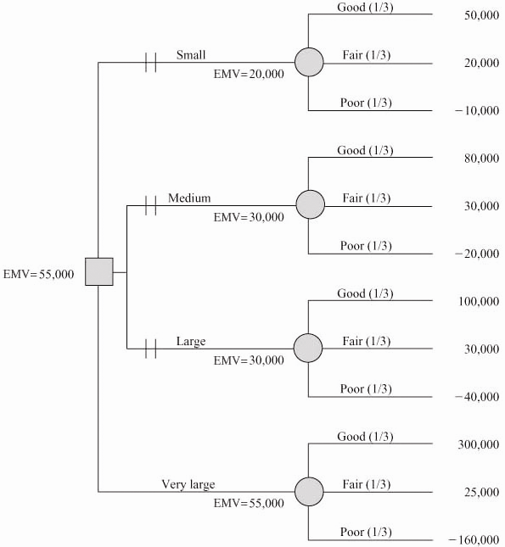
The first station should be very large, with EMV = $55,000
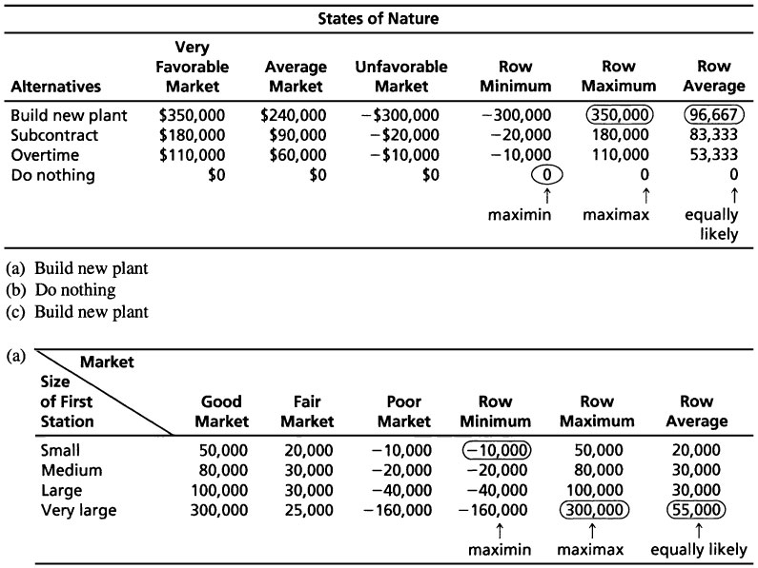
(b) Maximax decision: very large station
(c) Maximin decision: small station
(d) Equally likely decision: very large station
(e)
A.3 (a) EMV (large stock) = 0.3(22) + 0.5(12) + 0.2(–2) = 12.2
EMV (average stock) = 0.3(14) + 0.5(10) + 0.2(6) = 10.4
EMV (small stock) = 0.3(9) + 0.5(8) + 0.2(4) = 7.5
Maximum EMV is large inventory = $12,200
(b) EVPI = $13,800 – 12,200 = $1,600
where: $13,800 = 0.3(22) + 0.5(12) + 0.2(6)
A.4 Note: In the text, the states of nature appeared in the left column and the decision alternative across the top row. This is to let students know that data are sometimes presented in alternative formats.
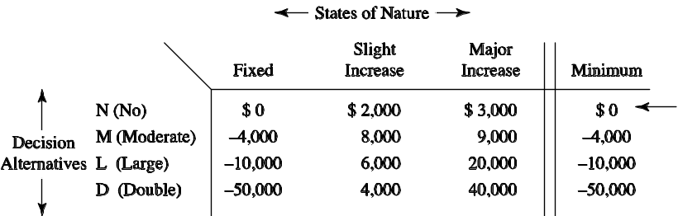
(a)
(b) using the maximin criterion; No floor space (N).
A.5 (a) EMV (assembly line) = (0.4)($10,000) + (0.6)($40,000)
= $28,000
EMV (plant) = (0.4)(– $100,000) + (0.6)($600,000) = $320,000
EMV (nothing) = 0
Select the new plant option.
(b) EVPI = $364,000 − 320,000 = $44,000

A.6 |  | Row Average
 | Increasing capacity | $700,000
 | Using overtime | $700,000
 | Buying equipment | $733,333 ←
Using equally likely, “Buying equipment” is the best option.

A.8 (a) Expected cost of hiring full-timer = 0.2(300) + 0.5(500) +
0.3(700)
A.7 (a) EMV (Alt. 1) = (0.4)(10,000) + (0.6)(30,000)
= $22,000
EMV (Alt. 2) = (0.4)(5,000) + (0.6)(40,000) = $26,000
EMV (Alt. 3) = (0.4)(−2,000) + (0.6)(50,000)
= $29,200
So the Max EMV is Alternative 3.
(b) Expected value with perfect information = (0.4)(10,000)
+ (0.6)(50,000)
= $34,000
(c) EVPI = $34,000 − $29,200 = $4,800.
= $60 + 250 + 210
= $520
Expected cost of part-timers = 0.2(0) + 0.5(350)
+ 0.3(1,000)
= $0 + 175 + 300
= $475
Thus, use part-time lawyers.

A.8 (b)
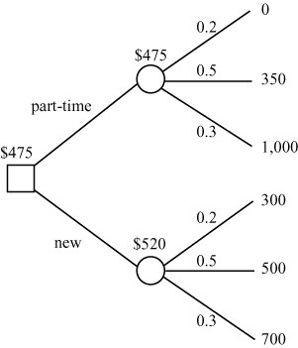
As consistent with part (a), she should hire part-time lawyers.
A.9 (a) Under conditions of risk, the company should choose batch processing, with an expectation of $1,000,000, which is twice as high as the next best choice.
(b) EVPI is $170,000.
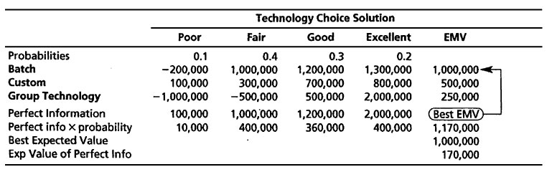
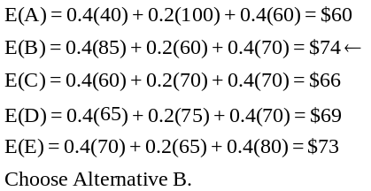A.10

A.11 (a) The primary challenge in this problem is constructing the payoff table. Each book stocked and sold results in a $30 profit. That’s $2100 for the combination 70–70. Each book stocked but not sold results in a $46 loss. Demand that cannot be satisfied results in no loss of revenue or profit. Profit from each book sold = $112 – 82 = $30. Loss from each book bought but not sold = $82 – 36 = $45. Thus the payoff table is
 | Demand
 | 70 | 75 | 80 | 85 | 90
Stock | p = 0.15 | p = 0.30 | p = 0.30 | p = 0.20 | p = 0.05
70 | 2100 | 2100 | 2100 | 2100 | 2100
75 | 1870 | 2250 | 2250 | 2250 | 2250
80 | 1640 | 2020 | 2400 | 2400 | 2400
85 | 1410 | 1790 | 2170 | 2550 | 2550
90 | 1180 | 1560 | 1940 | 2320 | 2700
(b)
 | EMV
Stock 70 | 2,100
Stock 75 | 2,193
Stock 80 | 2,172
Stock 85 | 2,037
Stock 90 | 1,826
Best EMV = 2,193

The largest EMV is associated with the action: Stock
75 books.

A.12 Profit from each case sold: $95 – $45 = $50. Loss from each case produced but not sold: $45.
Demand (Cases)
Production  (Cases) | 6  p = 0.1 |  |  |  | 7  p = 0.3 |  |  | 8  p = 0.5 |  |  | 9  p = 0.1 | EMV
6 | 300 |  |  |  | 300 |  |  | 300 |  |  | 300 | $300.00
7 | 300 |  |  |  | 350 |  |  | 350 |  |  | 350 | $340.50
 | –45
 |  |  | 255
8 | 300 |  |  |  | 350 |  |  | 400 |  |  | 400 | $352.50
 | –90 |  |  |  | –45
 |  |  | 210 |  |  | 305
9 | 300 |  |  |  | 350 |  |  | 400 |  |  | 450 | $317.00
 | –135 |  |  |  | –90 |  |  | –45
 |  | 165 |  |  |  | 260 |  |  | 355
* She should manufacture eight cases per month.
A.13 Note: All dollar values in $1,000s
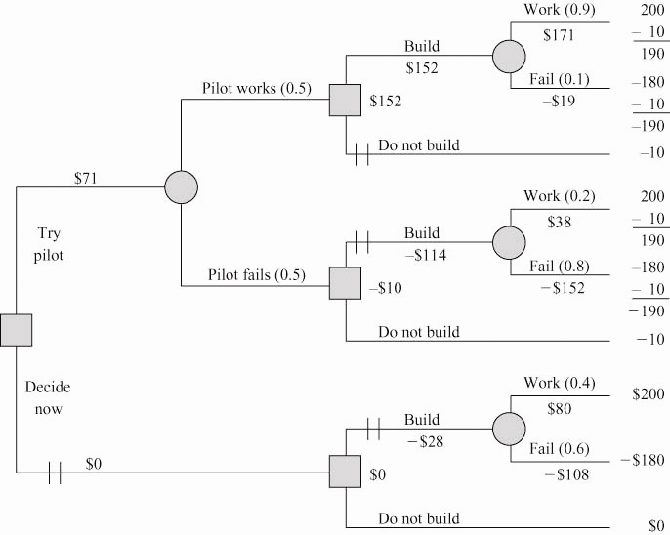
The recommended strategy (EMV = 71) is
- Try pilot
- If pilot is success: build plant
If pilot is failure: do not build plant
Note: All costs/revenues have been entered at the end of the branches of the tree.

A.14 Note: All dollar values are in 1,000s.
(a)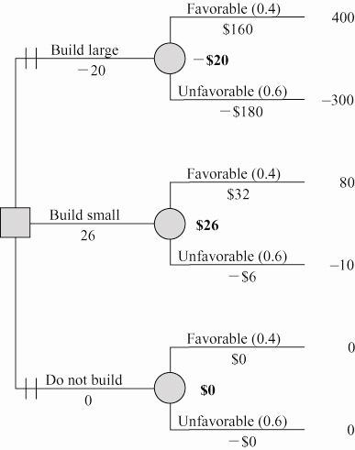
(b) Based on the expected monetary value criterion, Karen should elect to build a small plant.

(c) We can find the EVPI from the following:
- Expected value under certainty = (0.4)(400,000)
+ 0.6(0)
= $160,000
- Maximum EMV = $26,000
- EVPI = $160,000 – $26,000 = $134,000

A.15 (a)
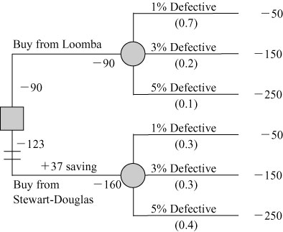
(b) Tests should be purchased from Loomba Technologies.
A.16 (a) Maximum EMV = $11,700 [= .3(15) + .5(12) + .2(6)]
(b) EV with PI = .3(20) + .5(12) + .2(6) = 13,200
EVPI = 13,200 – 11,700 = 1,500
A.17 (a) Analysis of the decision tree finds that Resort has a higher EMV ($76) than Home
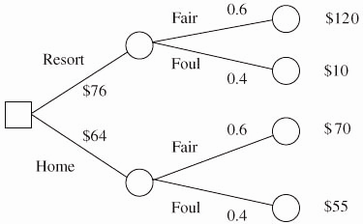
(b) EMV (Resort) = 0.6(120) + 0.4(10) = $76
EMV (Home) = 0.6(70) + 0.4(55) = $64
Choose resort.

A.18
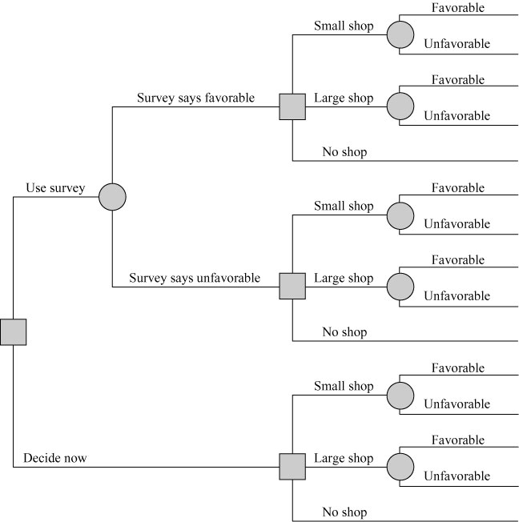

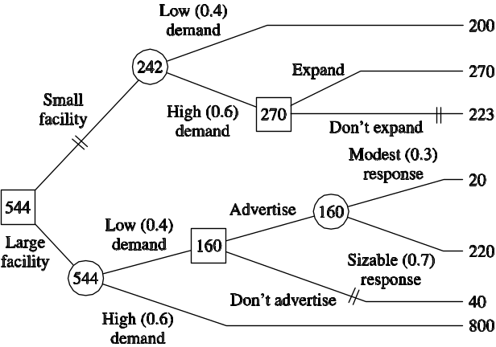
A.19 More than one decision is involved, and problem is under risk, so use a decision tree approach:
Note: Payoffs and expected payoffs are in $1,000s
(a) Build the large facility. If demand proves to be low, then advertise to stimulate demand. If demand proves to be high, no advertising is needed (so don’t advertise)
(b) Expected payoff: $544,000.
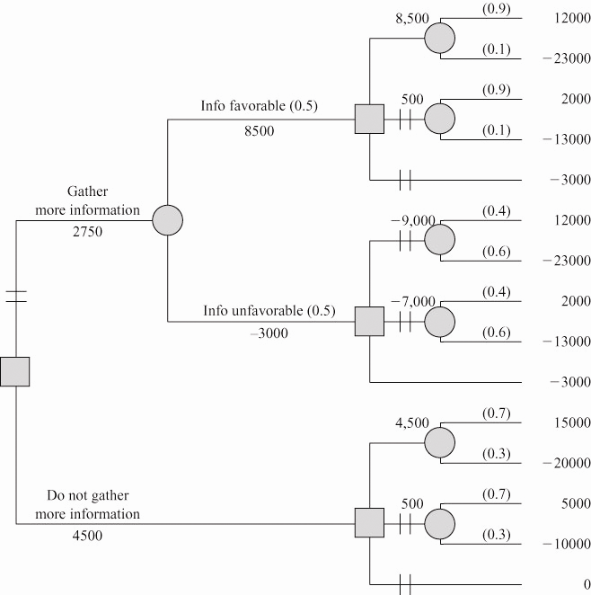

A.20

Your advice should be to not gather additional information and to build a large video section.
A.21 Solution approach: Decision tree, since problem is under risk and has more than one decision:
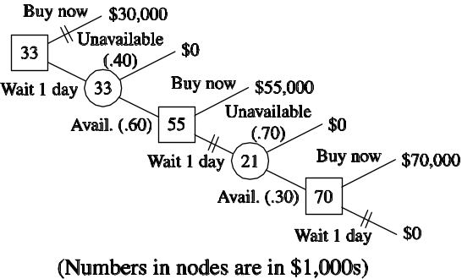

Maximum expected profit: $33,000. Jeff should wait 1 day. Then, if an XPO2 is available, he should buy it. Otherwise, he should stop pursuing an XPO2 on the wholesale market.
A.22 (a)
A
Decision | At X |  |  | At Y |  |  |  | At X |  |  | At Y
X | 45–27 |  |  | 9–27 |  |  |  | 18 |  |  | –18
Y | 6–15 |  |  | 30–15 |  |  |  | –9 |  |  | 15
X&Y | (45 + 6)–(27 + 15) |  |  | (30 + 9)–(27 + 15) |  |  |  | 9 |  |  | –3
Nothing | 0 |  |  | 0 |  |  |  | 0 |  |  | 0
Probability |  | .45 |  |  | .55 |  |  |  | .45 |  |  | .55

.25 (b) EMV (X) = .45(18) + .55(–18) = –1.8
EMV (Y) = .45(−9) + .55(15) = 4.2 ← Best
EMV (X&Y) = .45(9) + .55(−3) = 2.4
EMV (Nothing) = 0
Y is best choice

A.23 The EMV of this game is $0.59, as illustrated in the diagram below:

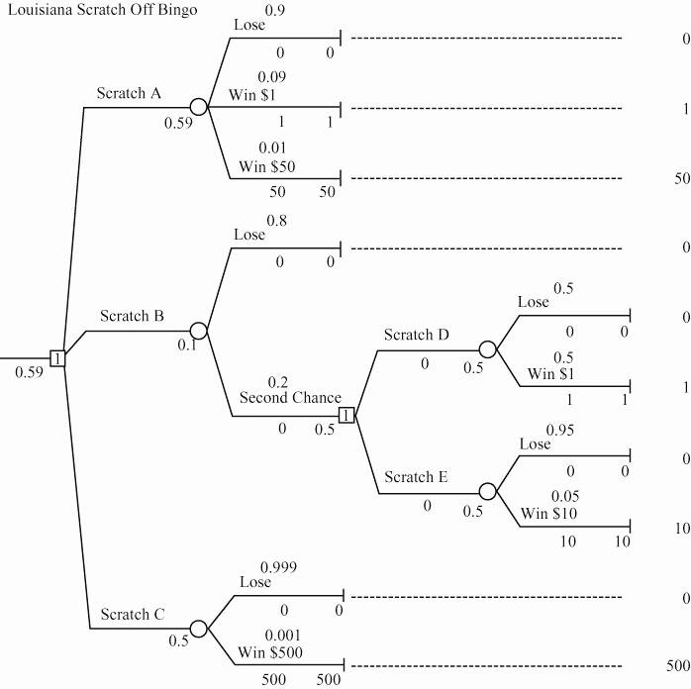
A.24

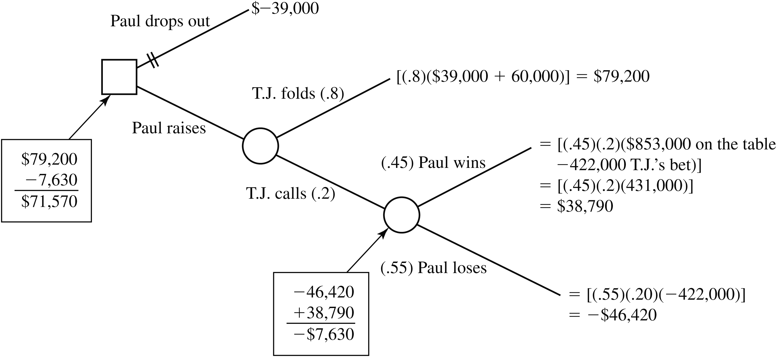

Additional Homework Problems
Here are solutions to the additional homework problems that appear on www.myomlab.com.
A.25
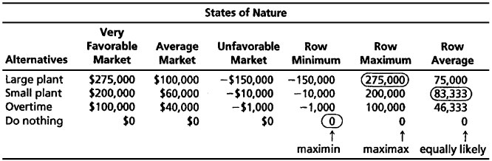
(a) Large plant
(b) Do nothing
(c) Small plant

A.26 (a) EMV (Alt. 1) = (0.4)(80) + 0.3(120) + 0.3(140)
 | Demand  11 Cases  P = 0.45 |  |  | Demand  12 Cases  P = 0.35 |  |  | Demand  13 Cases  P = 0.20 | EMV
Stock 11 cases | 385 |  |  | 385 |  |  | 385 | $385.00
Stock 12 cases | 385 |  |  | 420 |  |  | 420 | $379.05
 | −56
 |  | 329
Stock 13 cases | 385 |  |  | 420 |  |  | 455 | $341.25
 | −112 |  |  | −56
 |  | 273 |  |  | 364

= 32 + 36 + 42 = 110 = max. EMV
A.24
EMV (Alt. 2) = (0.4)(90) + 0.3(90) + 0.3(90)
= 36 + 27 + 27 = 90
EMV (Alt. 3) = (0.4)(50) + 0.3(70) + 0.3(150)
= 20 + 21 + 45 = 86
(b) EVPI = 117 − 110 = 7
A.27 Large has EMV = $75,000; small has EMV = $83,333; overtime EMV = $46,333; and do nothing = $0.

A.28 (a)

The recommended course of action, based on the expected monetary value criterion, is to stock 11 cases.
(b) It should be intuitively obvious that if no loss due to overstocking is involved, one should always carry the maximum stock. This observation is confirmed by the following table.
 | Demand  11 Cases  P = 0.45 | Demand  12 Cases  P = 0.35 | Demand  13 Cases  P = 0.20 | EMV
Stock 11 cases | 385 | 385 | 385 | $385.00
Stock 12 cases | 385 | 420 | 420 | $404.25
Stock 13 cases | 385 | 420 | 455 | $411.25
The recommended course of action, based on the expected monetary value criterion, is to stock the maximum of 13 cases.

A.29 Note: All dollar values are in 1,000s.
(a)
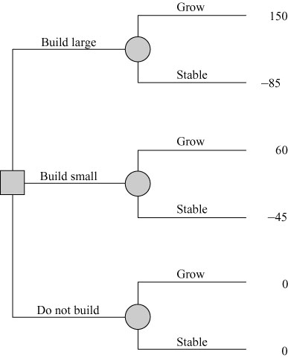
(b) |  | Population Trend  Growth | Stable
Build large wing |  | 150 | − 85
Build small wing |  | 60 | − 45
 | Do not build | 0 | 0

(c)
Population Trend
 | Growth (P = 0.5) | Stable (P = 0.5) | EMV
Build large wing | 150 | −85 | $32.50
Build small wing | 60 | −45 | $7.50
Do not build | 0 | 0 | $0.00
Based on the expected monetary value criterion with the assumption that the states of nature are equally likely, she should build the large wing.
(d)
Population Trend
 | Growth (P = 0.6) | Stable (P = 0.4) | EMV
Build large wing | 150 | −85 | $56.00
Build small wing | 60 | −45 | $18.00
Do not build | 0 | 0 | $0.00
Based on the expected monetary value criterion, she should build the large wing.
A.30 (a)

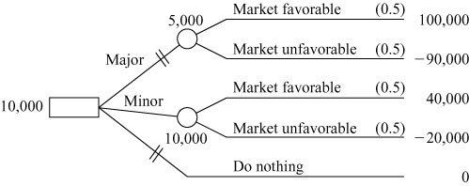

(b) EMV (major renovation) = 5,000
EMV (minor renovation) = 10,000*
* Best decision is minor renovation
A.31 The EMV for A1 is
0.3 × 10,000 + 0.5 × 20,000 + 0.2 × 6,000 = 14,200.
The EMV for A2 is
0.3 × 5,000 + 0.5 × 30,000 + 0.2 × 15,000 = 19,500.
A2 has the higher EMV, and is the more profitable.
A.32 The EMV of Alternative A is $1,400,000
Alternative B is $1,350,000.
Alternative C is $250,000.
The highest EMV is found in Alternative A, but many
students will choose the slightly smaller, but decidedly less risky B.
EMV is most reliable when the decision is repeated many times.
The choice of A assumes a large number of replications; the
choice of B assumes a problem solved perhaps only once.

Case Study
TOM TUCKER’S LIVER TRANSPLANT
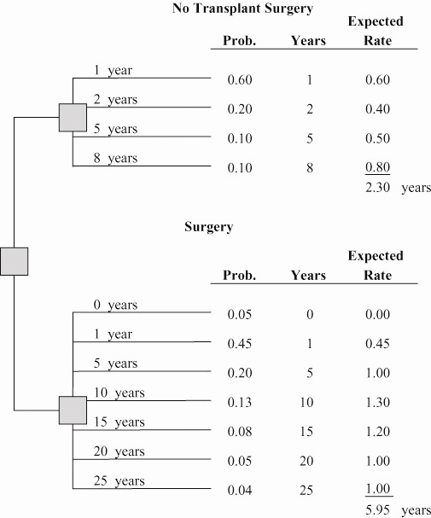

Expected survival rate with surgery (5.95 years) exceeds the
nonsurgical survival rate of 2.30 years. Surgery is favorable.
Other factors might include the particular doctor and hospital used and care received.
Additional Case Studies*
*These case studies appears on our Companion Web site, www.pearsonhighered.com/heizer.

ARCTIC, INC.
1
No probabilities have been included in this case study. As an initial analysis, we expect students to input the data and run Excel OM or POM for Windows.
Student analysis would be to determine something about maximax, maximin, equally likely, and the expected values. Because the probabilities are not known, a first try might be to assign equal probabilities—say, 0.1666. The best expected value is given by “building new,” with a value of nearly 2. However, note that this value is not that much greater than the value for “expanding” the plant. “Purchasing” has a terrible expected value of (0.35) and can be eliminated. “Sole sourcing” also has a low expected value and can possibly be eliminated from consideration. The question that remains is this: How sensitive are the results to the scenario probabilities? This is where the power of a computer comes in handy. Students can try many different probability combinations and look at the expected values. We are primarily concerned with expanding, building new, subcontracting, and expanding and subcontracting.
As “drop” is the worst scenario, try probabilities of 0.125, 0.125, and 0.25 for grow, stable, and drop, respectively. In this case, “expand” or “expand and subcontract” are better options. To determine the effects of growth, reverse the probabilities. This brings “building new” to the forefront. It is impossible to give an exact answer on what option to choose. The analysis shows that building a new plant can be very profitable, but this strategy can also be very risky. It might be more prudent to focus on the two expansion strategies.

SKI RIGHT CORP.
2

1. Bob can solve this case using decision analysis. As you can see, the best decision is to have Leadville Barts make the helmets and have Progressive Products do the rest with an expected value of
$2,600 per month. The final option of not using Progressive, however, was very close with an expected value of $2,500 per month.
 | Poor ($) | Average ($) | Good ($) | Excellent ($) | Expected  Value |  |  | Row  Minimum |  |  | Row  Maximum
Probabilities | 0.1 | 0.3 | 0.4 | 0.2
Option 1—PP | −5,000 | −2,000 | 2,000 | 5,000 | 700 |  |  |   −5,000 |  |  | 5,000
Option 2—LB | −10,000 | −4,000 | 6,000 | 12,000 | 2,600 |  |  | −10,000 |  |  | 12,000
and PP
Option 3—TR | −15,000 | −10,000 | 7,000 | 13,000 | 900 |  |  | −15,000 |  |  | 13,000
and PP
Option 4—CC | −30,000 | −20,000 | 10,000 | 30,000 | 1,000 |  |  | −30,000 |  |  | 30,000
and PP
Option 5—LB, | −60,000 | −35,000 | 20,000 | 55,000 | 2,500 |  |  | −60,000 |  |  | 55,000
CC, and TR
Column Best |  |  |  |  | 2,600 |  |  |   −5,000 |  |  | 55,000
The maximum expected monetary value is $2,600 per month
given by Option 2—LB and PP.

3. There are a number of options that Bob did not consider. See if students can list one or more of these options.
2. The expected value of perfect information is presented below.
The EVPI is $15,300.
Perfect Information
 | Poor Market | Average | Good | Excellent
Probabilities | 0.1 | 0.3 | 0.4 | 0.2
Option 1—PP | –5,000 | –2,000 | 2,000 | 5,000
Option 2—LB and PP | –10,000 | –4,000 | 6,000 | 12,000
Option 3—TR and PP | –15,000 | –10,000 | 7,000 | 13,000
Option 4—CC and PP | –30,000 | –20,000 | 10,000 | 30,000
Option 5—LB, CC, and TR | –60,000 | –35,000 | 20,000 | 55,000
Perfect Information | –5,000 | –2,000 | 20,000 | 55,000
Perfect info × Probability | –500 | –600 | 8,000 | 11,000
The expected value with certainty = 17,900
The expected value = 2,600
The expected value of perfect information = 15,300

